To make an LED blink using an ESP8266, you can use the Arduino IDE to upload a simple sketch. Here's a step-by-step guide:

**Materials Needed**

* ESP8266 module (like NodeMCU or Wemos D1 Mini)
* LED
* Resistor (220Ω or 330Ω)
* Breadboard and jumper wires

**Circuit Setup**

1. Connect the longer leg of the LED (anode) to a GPIO pin on the ESP8266 (e.g., D1).
2. Connect the shorter leg (cathode) to one end of the resistor.
3. Connect the other end of the resistor to the ground (GND) on the ESP8266.

**Arduino Code**

1. Open the Arduino IDE.
2. Install the ESP8266 board package if you haven’t done so.
3. Select your ESP8266 board from the Tools menu.
4. Use the following code:

#define LED_PIN D1 // Use the appropriate GPIO pin

void setup() {

pinMode(LED_PIN, OUTPUT); // Set the LED pin as an output

}

void loop() {

digitalWrite(LED_PIN, HIGH); // Turn the LED on

delay(1000); // Wait for a second

digitalWrite(LED_PIN, LOW); // Turn the LED off

delay(1000); // Wait for a second

}

**Uploading the Code**

1. Connect your ESP8266 to your computer.
2. Select the correct port in the Tools menu.
3. Click the upload button.

**Result**

After uploading, the LED should blink on and off every second.

## **ESP8266 Pinout in Arduino IDE:**

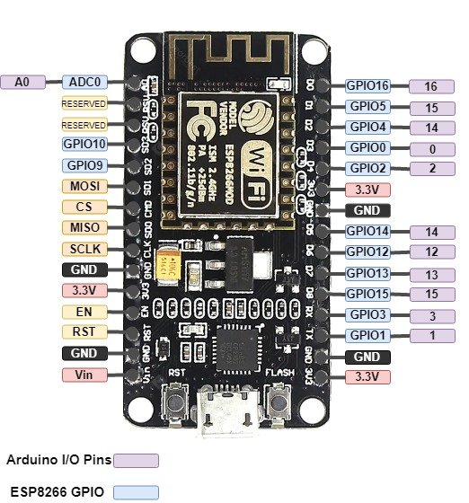

|  |  |  |
| --- | --- | --- |
| **Arduino IDE Pins Index** | **ESP-12E** | **ESP8266 GPIO** |
| **A0** | **A0** | **ADC 0** |
| **0** | **D3** | **GPIO 0** |
| **1** | **D10** | **GPIO 1** |
| **2** | **D4** | **GPIO 2** |
| **3** | **D9** | **GPIO 3** |
| **4** | **D2** | **GPIO 4** |
| **5** | **D1** | **GPIO 5** |
| **12** | **D6** | **GPIO 12** |
| **13** | **D7** | **GPIO 13** |
| **14** | **D5** | **GPIO 14** |
| **15** | **D8** | **GPIO 15** |
| **16** | **D0** | **GPIO 16** |